FOCUS

SUMMER
2021
Dundee Blind and Partially Sighted Society
Thomas Herd House
10-12 Ward Road
Dundee DD1 1LX

Telephone: 01382 227101
E-mail: office@dbpss.org.uk
Website: www.dundeeblindsociety.org.uk

Alison’s Letter

Hello everyone,

Well, haven’t things moved in the right direction since my last letter!

I am hoping that by the time you receive this Focus, you will all have had an opportunity to meet up with your friends and loved ones, and maybe even had a hug!!

You will all have received the communication regarding restarting some activities on the 19th July and at present that is still on the cards, with fingers and everything else crossed that we can go ahead!!

We are very much looking forward to welcoming back Members to activities and I hope that we see some new faces! We have spent the last 14 months getting to know our Members and it would be lovely to meet face to face!

We are keeping a close eye on the Scottish Government guidance for the social distancing rules etc as this will dictate how many Members we can welcome at once but I will be contacting all those that would like to come into the Society to take part in activities nearer the time, but if you didn’t attend previously but would like to give us a go, please let us know and we will put you on the lists.

Myself, Jenni and Ainslay have now had our first vaccination and waiting for our appointments for the second.

We have started to visit Members in their gardens and if you would like a chat in your garden, please give us a ring and we can arrange – we even bring our own chair and refreshments, so we are really no trouble!

We sadly said goodbye to the minibus, we felt that it was not that easy to get in and out of due to the height of the steps, and it will not be able to be used due to the social distancing restrictions.

We have also been doing some training to prepare for our return and we have all completed our Food & Hygiene certificates so we will be able to whip up some lovely food for you when we get back to activities!

You may have noticed that I have changed the title of my letter from ‘Manager’s’ to ‘Alison’s’, this is because the Board have changed my job title to Chief Executive Officer but my position and role has not changed, and I am still as available and approachable as I’ve ever been.

That’s all for now, but hopefully when I am doing my Autumn letter I will be able to report on a successful return to some activities!

Take care and best wishes
Alison

LATEST CORONAVIRUS ADVICE
17th May

The latest advice from the Scottish Government is that we are now in Level 2.

I am sure you are all well aware of the following information but here is a quick recap of what you can do in Level 2

Indoor socialising – you can now meet up to 6 people from households in your own home and people can now stay overnight.

Travel – you are now allowed to travel freely throughout the UK (but not to areas in a higher level), although face masks must still be worn on public transport unless exempt. Hotels and holiday accommodation can open.

Hospitality – You can now visit a restaurant/bar and have a glass of wine or your favourite beverage inside, with or without a meal.

Shopping – All shops allowed to open.

Leisure & Entertainment – Cinemas, theatres, bingo halls etc, allowed to open.

Visits to Hospitals – Recommended family support from at least 1 visitor per patient (anymore is at the discretion of the hospital management)

Visits to Care Homes – Recommended minimum of 2 indoor visits per week, one person at a time. Essential visits at all times.

If you would like any further information that isn’t covered above, please get in touch and we will try to help you find the information you are looking for.

Shopping Assistance
We are conscious that some of you may not be feeling very confident about venturing out to the shops, but that’s ok, we feel the same.

To help build up your confidence and ours, we are offering our Members a new service where we can take them shopping, could be for food, clothes, something new for house or gifts etc.

It has also come to our attention that some Members are finding it difficult to pay for items now that many shops are cashless and the contact payment limit is £45, so accompanying you shopping we could also give you guidance on putting in your pin number (you would not tell us your pin)

If you would like to venture out to the shops and would like some company, please let us know.

Garden Visits
We have now had a few visits to the gardens of our Members, and it was so lovely to see them again after so long and to catch up on a good gossip! I have to say that the first one was a bit chilly so it is reliant on the weather but if you would like some company for an hour, please let us know and we will arrange a date.

Audiobooks
We are still offering our audiobooks delivery and collection service and we were very thankful and grateful for a legacy donation of £150 for the audiobook library so Ainslay and Jenni are going to be going shopping for new audiobooks very shortly – which is maybe just as well as I know many of you are working your way through our entire library!!

Please give us a call if you would like a delivery of audiobooks.

Welfare phone calls
The phone calls and remote support that we have given over the last 14 months has been very much appreciated by both Members and us. We are very keen to stress that just because things are starting to get back to normal and Members can return to the Society in July that we will not be abandoning the Members that have been receiving calls.

If you would like to continue with your calls, please just let Ainslay or Jenni know when you speak to them. We will be setting time aside during our working days to continue with the calls and audiobooks delivery.

Resource Room
If you need anything from the Resource Room, please give us a call and we can make an appointment for you to visit the Resource Room.
Staff Training
Alison, Ainslay and Jenni have embarked on training from Associated Optical to help us to help you! We will hopefully be able to carry out low vision assessments when the social distance restrictions allow.
We will keep you posted!
International Year of the Older Person
1st October 2021 marks 30 years since the first United Nations International Year of the Older Person Day and to celebrate Dundee Volunteer and Voluntary Action have partnered up with Dundee Pensioners Forum to make the year extra special. They are doing a number of initiatives which some of older Members may wish to be involved in (Thank you to the DVVA website for the information below)
Ordinary People Doing Extraordinary Things
The DVVA wants to hear from older people “to celebrate the contribution that they make to our City as ordinary people doing extraordinary things. Whether you are a volunteer or are a kinship carer looking after you grandchildren in order to keep your family unit afloat, then we want to hear from you and say thanks. If you would like to nominate yourself or someone else, then we would love to hear from you”
If you would like to be included in either project and would like to share your story, please get in touch with Rachel on 01382 305700 or email racheljackson@dvva.scot

Reminiscence Projects
“In keeping with our story sharing, we are to be working in partnership with over the next few months to do some reminiscence projects. V&A Dundee are asking for our help to explore the significance of a vast postcard collection produced by former global printing firm J. Valentines & Sons of Dundee and wants to uncover stories from the firm’s print and photographic past – and they would like former workers’ help to record those generations of social history.
If you or your family worked at Valentines, they are keen to find out what your role was, what you did each day, and what the experience was like? What role did Valentines play in your life and how is the firm remembered across the city? Even if you didn’t work at Valentines, you can still get involved”
Anyone interested in getting involved should contact Nicola Mitchell on 01382 305745 or email nicolamitchell@dvva.scot
See Me, Hear My Voice Campaign

June Costello – See Me, Hear My Voice
Until 30th September 2021, Dundee Volunteer and Voluntary Action are organising a variety of projects for older people aged 55+. One of the projects, See Me, Hear My Voice aims to tell the stories of Dundee’s older population and attempt to challenge negative stereotypes and inspire the younger generation. The projects will culminate in an exhibition and a book.
June, one of our lovely Members, agreed to take part in See Me, Hear My Voice. We met, following Government guidelines, in June’s garden situated in ‘Lochee Riveria,’ as June calls her neighbourhood when it’s sunny.
The See Me, Hear My Voice form has 5 questions:-

Name and Age – June, and a lady never tells!

Occupation/previous occupation - June worked as a canteen worker at Transco providing holiday relief for several years.

A word used by others to describe yourself (good, bad or indifferent) - As anyone who knows June will realise, one word to describe her, is impossible! She’s kind, funny, spontaneous, vivacious, adventurous and….daft. According to June, daft is the word others would probably use to describe her, because she’ll try anything interesting. Which leads us on to the last question on the form…

Tell us something people might not know about you - For over the last 16 years June has volunteered as a Case Study patient to help student doctors from around the world develop their clinical and communication skills in Ninewells Hospital. June has retinitis pigmentosa and macular degeneration and is registered blind. As part of their exams, students have to examine June and diagnose her conditions. June really enjoys volunteering and has met lots of interesting people while helping students develop their skills.

Many thanks to June for taking part in See Me, Hear My Voice and if anyone would like help to get involved in this project or share memories or thoughts about a particular place in Dundee, please let us know on 01382 227101.

RNIB Living with Sight Loss courses
RNIB are continuing to run their Living Well with Sight Loss courses for people with Sight Loss. They are running the course remotely, mostly by telephone but with also with some video courses.
Alan Greig is running telephone courses that last for 6 sessions for people with sight loss in Scotland to give attendees practical advice, information and guidance on organisations, products and services that are available to help. Attendees also have the chance to learn from each other's personal experiences and share top tips. Some of the courses are more locally aimed and some of our courses are open to anyone living in the UK.

For more information or if you would like assistance in being referred on to a course, please get in touch with Alison on 227101.

Dundee Community Cars
Dundee Community Cars is local charity that provides affordable and accessible transport to those aged over 65 in Dundee.
The charity has now restarted its service in a safe and Covid compliant way.
It’s easy to become a member of Community Cars, they only ask that you are 65 or over and don’t have access to your own car and can’t generally use public transport. You must live within Dundee to use Community Cars, but thanks to the generosity of our volunteers we can sometimes take you to another local town or city.
To register as a customer of Community Cars there is an £5.00 annual membership fee (that’s less than 50p a month!)
Their drivers give up their time voluntarily but are reimbursed for the cost of wear and tear on their vehicles and so Dundee Community Cars do have to charge their customers for journeys. They have tried to keep this moderate at 55p per mile with a £4.00 minimum fee per journey taken which allows them to ensure our drivers are able to continue volunteering.
If you would like more information or to register as a customer, please contact Dundee Community Cars on 305721 or phone us at the Society and we can help you.

What we did in lockdown
Now that we are slowly starting to ease out of these awful lockdowns, we started to wonder what all our wonderful members did to occupy their time and keep their spirits raised throughout the pandemic. Ainslay managed to meet up with a few of the members (following government guidelines of course) to find out!

Stephen Walls – The Lego Master
Stephen is one of our younger clients whose biggest hobby is Lego models. Stephen once loved nothing more than a good jigsaw but due to his eyesight deteriorating, he could no longer do these so turned to Lego models instead.
Stephen has over 200 models displayed around his home, 12 of which he built over lockdown. These include, The Taj Mahal, a JCB truck and a Lego dots Mickey Mouse portrait.
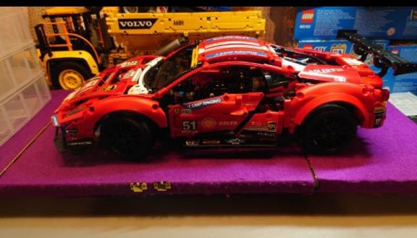
The Taj Mahal took a staggering six weeks to complete with the help of a digital magnifier. The digital magnifier is Stephen’s saviour and without it would have never managed to complete the 5,900 piece beauty. Stephen also managed to program the JCB truck to his phone in order for it to move.
Stephen and his Mum have spent over £2,000 on Lego models and said without these keeping him occupied, and of course his 12 year old dog Sheeba keeping him company, he fears his mental health problems would have taken him to darker places.
Stephen has started to study Lego and all the hidden clues the models hold for upcoming pieces. He has no intention of stopping now and next on his growing list is the London bus and the Bugatti Chiron sports car.

The Anonymous Baker
One of our more modest members who wishes not to be named has survived lockdown with the help of her friends and neighbours. These wonderful people came to her aid and decided they would help by doing all of her shopping etc as she was advised to shield throughout the pandemic.
This wonderful member got down to business and as a thank you to her helpers began to bake delicious goodies for them. Some of the goodies included Victoria sponges, lemon drizzle cake, banana loaf, treacle scones and shortbread, the list is endless!
Our member says she is eternally grateful for all the help she received and would have struggled to cope without her wonderful helpers.

Madeline Stupart – The Tapestry Queen
Throughout the pandemic Madeline decided to tap into her creative side and use her embroidery skills to make beautiful tapestries. She worried that being confined to the house would lead to her experiencing poor mental health so took what she used to do now and again and applied it to her everyday routine.
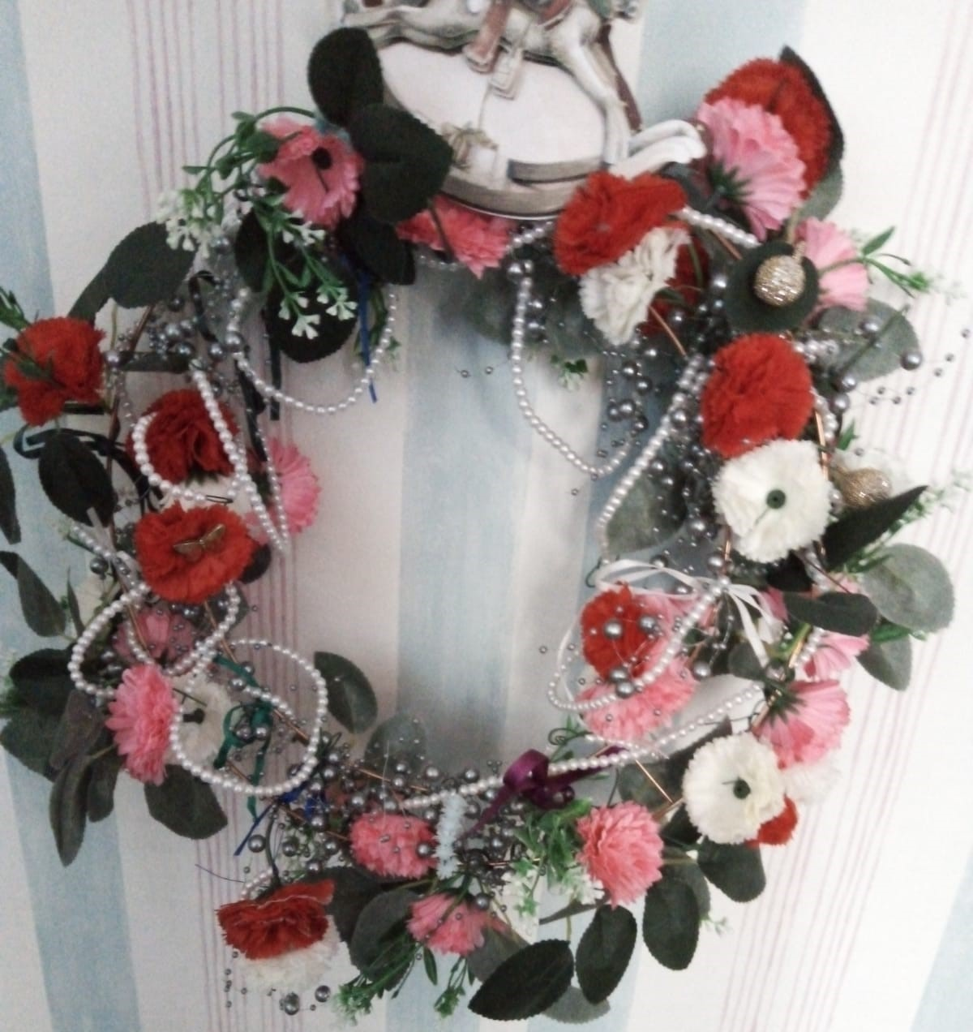
Madeline has created a number of pieces which she has also framed for display. She also created a stunning door wreath from the “ bits and bobs” she had lying around the house.
Madeline said thanks to the skills she has she was able to get through both lockdowns and come out smiling.

Well ladies and gentlemen, that’s just a few of the feelgood stories that have come to light, and we would just like to say a huge well done to each of them. All of them are a true inspiration of what you can achieve despite having a visual impairment. If anyone else has a story to share please contact us on 01382 227101.

Fundraising Challenge
Through lockdown some of you probably had a chat with Gavin and he has very kindly offered to have a fundraising challenge for the month of June in aid of the Society - he has pledged to undertake 100 press ups and 100 sit ups every day in June!!!
If you would like to sponsor Gavin, please get in touch with us on 227101 or if you have access to the internet you can make a sponsorship payment on our website – thank you for any support, and thank you to Gavin for your pledge!!!!
“Scotch” Corner
It’s A Braw Brand New Day! Eh?
Did ye get oot yer bed
The wrang side the morn?
Did ye discover yer best goonie
Wus a’ maukit an torn?
Did ye forgot tae salute the sun
Oan yer yoga mat?
Did ye run oot o’ sauce
Fur yer smoked bacon bap?
Did ye no have yur furst
Café latte o’ the day?
Did ye stick oan yer baffies
An step in the litter tray?
C’mon noo, how dae ye feel
Aboot this braw brand new day?
Eh?
Ye’re auf back tae yer bed??
Crabbit Grannie’s Sayin’s
If his brains wur made o’ dynamite, he cuidnae blaw his hat auf
Ye’re awfy peely wally lookin’
Yon’ll nae set the heather oan fire!
This wan’s this jammy, if she fell in the Clyde she’d come out wi’ a salmon in her mooth

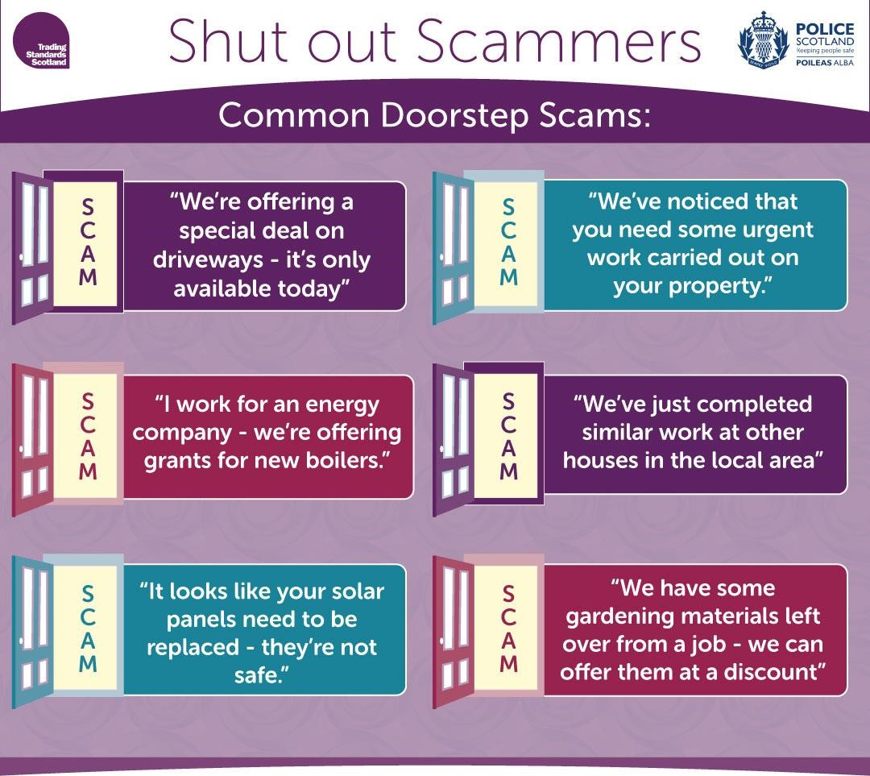

Report suspicious behaviour to Police Scotland on 101, or 999 in an emergency
Report scams to Advice Direct Scotland on 0808 164 6000 or at consumeradvice.scot
Sign up to receive Neighbourhood Watch Scotland Alerts at neighbourhoodwatchscotland.co.uk

Quick Quiz
Questions
- In which European city can you find the home of
Anne Frank?

- How many stars has the American flag got?

- How long is the Great Wall of China?

- What is the name of the Indian holy river?

- What animal has 3 hearts?

- What is the thinnest natural thread?

- Which nuts are used in marzipan?

- What malformation did Marilyn Monroe have when
she was born?

- How do pineapples grow?

- In what year was the Berlin walk built?

Puzzle Time
1 |  | 2 |  | 3 |  | 4 |  |  | 5 | 6 |  | 7
8 |  |  |  |  |  |  |  |  | 9
 |  |  |  |  |  |  |  | 10
 |  |  | 11
12 |  | 13
14 |  |  |  |  |  |  | 15
 |  |  |  |  |  | 16
17
 |  |  |  |  |  |  |  |  |  | 18 |  | 19
20 |  |  |  |  | 21
22 |  |  |  |  | 23

Clues Across
1 – bare faced cheek (8)
5 – vegetable (4)
8 – report (8)
9 – prison room (4)
11 – book-keeping (10)
14 – regard as the same (6)
15 – dashboard (6)
17 – course of study (10)
20 – move (a muscle) (4)
21 – African country (8)
22 – not as much (4)
23 – TV news and information service (8)

Clues down Crossword
1 – assistant (4)
2 – ship’s floor (4)
3 – newspaper cartoon (5,5)
4 – public-address system (6)
6 – telescope part (8)
7 – metric unit of weight (8)
10 – priceless (10)
12 – Calm, quiet (8)
13 – angry disagreements (8)
16 – to no avail (6)
18 – woodwind instrument (4)
19 – noteworthy act (4)

Word Search – RADIO CALL SIGNS

ALPHA JULIET TANGO
BRAVO KILO UNIFORM
ECHO LIMA VICTOR
FOXTROT MIKE YANKIE
GOLF QUEBEC ZULU

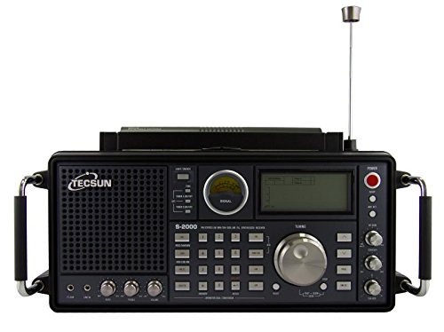

Word Search – RADIO CALL SIGNS

Z | L | O | H | I | R | B | G | Z | I | F | V
B | U | I | T | M | L | A | M | I | K | E | G
R | U | L | M | I | F | J | K | M | V | P | B
A | O | V | U | A | U | I | U | A | R | B | N
V | O | H | T | L | E | N | O | G | N | A | T
O | T | H | I | I | I | I | O | Y | L | N | O
U | T | E | C | F | O | L | K | A | U | A | F
L | T | R | O | E | I | X | F | N | H | R | L
M | L | R | O | K | T | O | E | P | A | C | O
F | M | S | U | T | X | G | L | O | E | Y | G
O | K | E | Q | T | C | A | L | B | A | I | O
Y | R | O | R | Z | I | I | E | M | E | O | A
F | E | O | J | H | E | U | V | K | L | U | C
R | T | L | C | U | Q | E | I | O | X | K | T

SuDoku – Each Horizontal /Vertical line must contain one and only one of each digit 1-9

 |  | 1 | 7 |  | 2 |  |  | 8
 |  |  | 5 | 6 |  |  |  | 9
9 | 2
 | 5 |  | 8 |  |  |  |  | 2
 |  | 9 |  |  |  | 7
1 |  |  |  |  | 4 |  | 8
 |  |  |  |  |  |  | 6 | 4
5 |  |  |  | 1 | 9
8 |  |  | 4 |  | 7 | 3

Quick Quiz

Answers

- Amsterdam
- Fifty - 50
- 4000 miles
- Ganges
- Octopus
- Spider web
- Almonds
- 6 toes
- On the ground

- In the year 1961

Puzzle Time Answers
A | U | D | A | C | I | T | Y |  | L | E | E | K
I |  | E |  | O |  | A |  |  |  | Y |  | I
D | O | C | U | M | E | N | T |  | C | E | L | L
E |  | K |  | I |  | N |  | I |  | P |  | O
 |  |  | A | C | C | O | U | N | T | I | N | G
P |  | Q |  | S |  | Y |  | V |  | E |  | R
E | Q | U | A | T | E |  | F | A | S | C | I | A
A |  | A |  | R |  | F |  | L |  | E |  | M
C | U | R | R | I | C | U | L | U | M
E |  | R |  | P |  | T |  | A |  | O |  | F
F | L | E | X |  | Z | I | M | B | A | B | W | E
U |  | L |  |  |  | L |  | L |  | O |  | A
L | E | S | S |  | T | E | L | E | T | E | X | T

3 | 6 | 1 | 7 | 9 | 2 | 4 | 5 | 8
7 | 4 | 8 | 5 | 6 | 3 | 2 | 1 | 9
9 | 2 | 5 | 1 | 4 | 8 | 6 | 7 | 3
6 | 5 | 3 | 8 | 7 | 1 | 9 | 4 | 2
4 | 8 | 9 | 2 | 5 | 6 | 7 | 3 | 1
1 | 7 | 2 | 9 | 3 | 4 | 5 | 8 | 6
2 | 9 | 7 | 3 | 8 | 5 | 1 | 6 | 4
5 | 3 | 4 | 6 | 1 | 9 | 8 | 2 | 7
8 | 1 | 6 | 4 | 2 | 7 | 3 | 9 | 5

